Editorial

The theoretical background for the activity was presented in “Books for English Children an Inspiration for Teaching English as a Foreign Language” by Hanna Kryszewska, HLT May 2008, issue 3 year 10.

Halloween: Writing Drill-based Texts for YL Learners
Students of English Unlimited Teachers Training College in Gdańsk, Poland.

Menu

Introduction

Examples
Conclusions

Introduction

The main idea of this article is how to create different texts which: have a drill at their core, practise vocabulary, practise grammar structures and are related to the theme of Halloween. The article itself consists of several different texts written by 3rd students – trainee teachers of English Unlimited Teachers Training College in Gdańsk 2007. The theoretical framework and authentic examples were provided by Hanna Kryszewska during the “Methods of Learning and Teaching” course.

Examples

The first set of texts shows how to introduce and drill new vocabulary. It is assumed that the learners are familiar with the grammar structures. The texts are illustrated by the trainee teachers’ own drawings.

Text 1
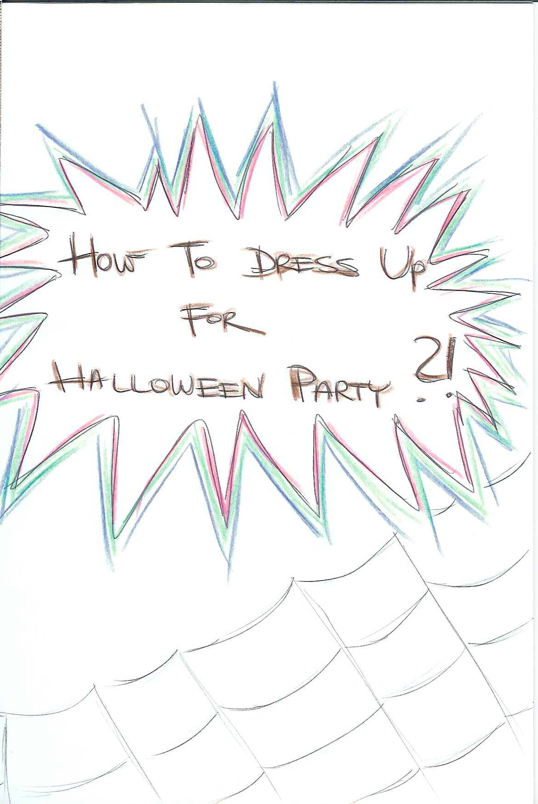
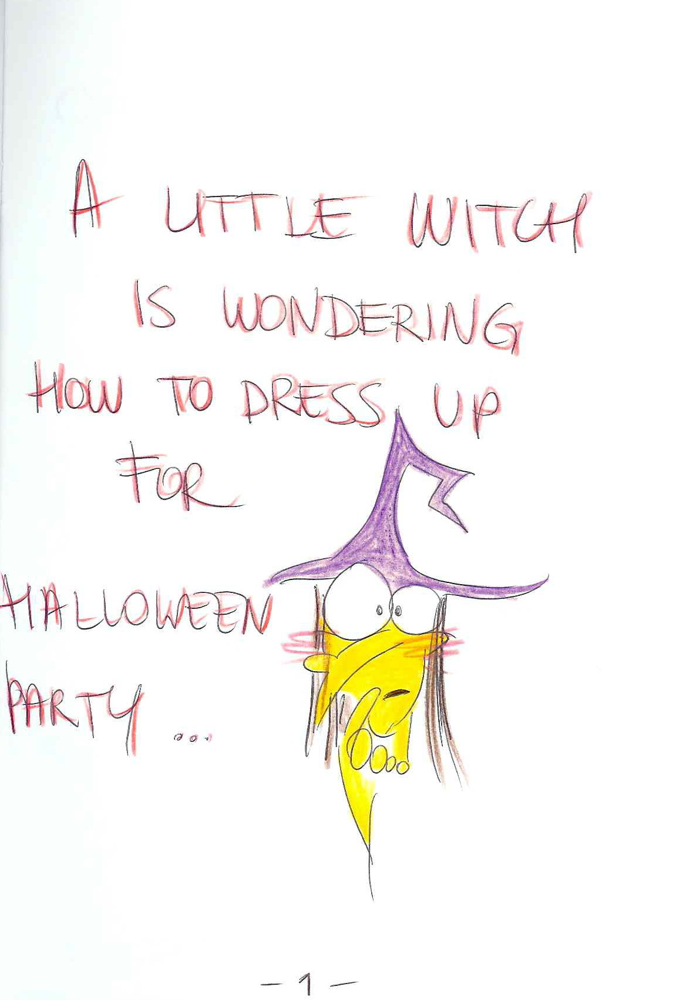
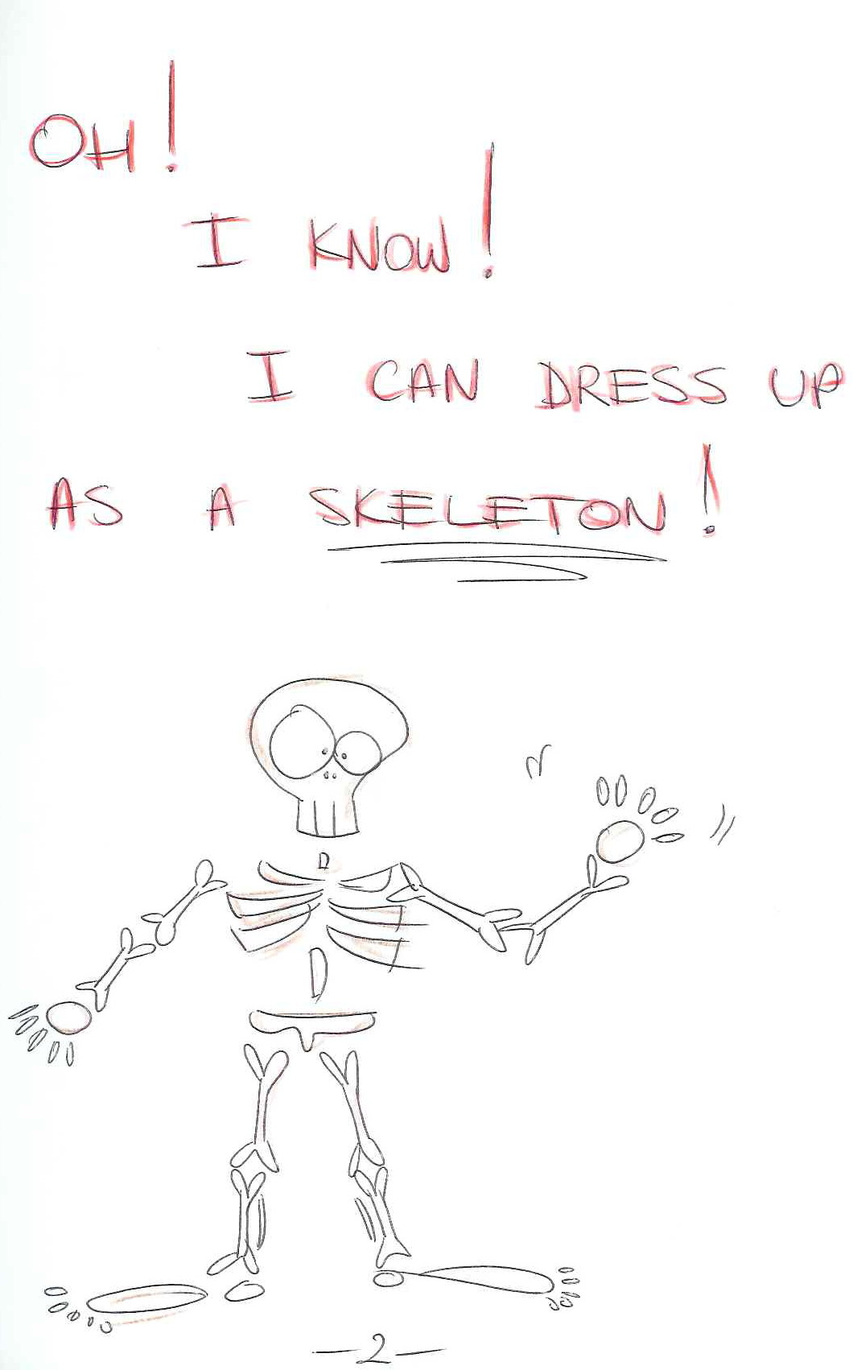

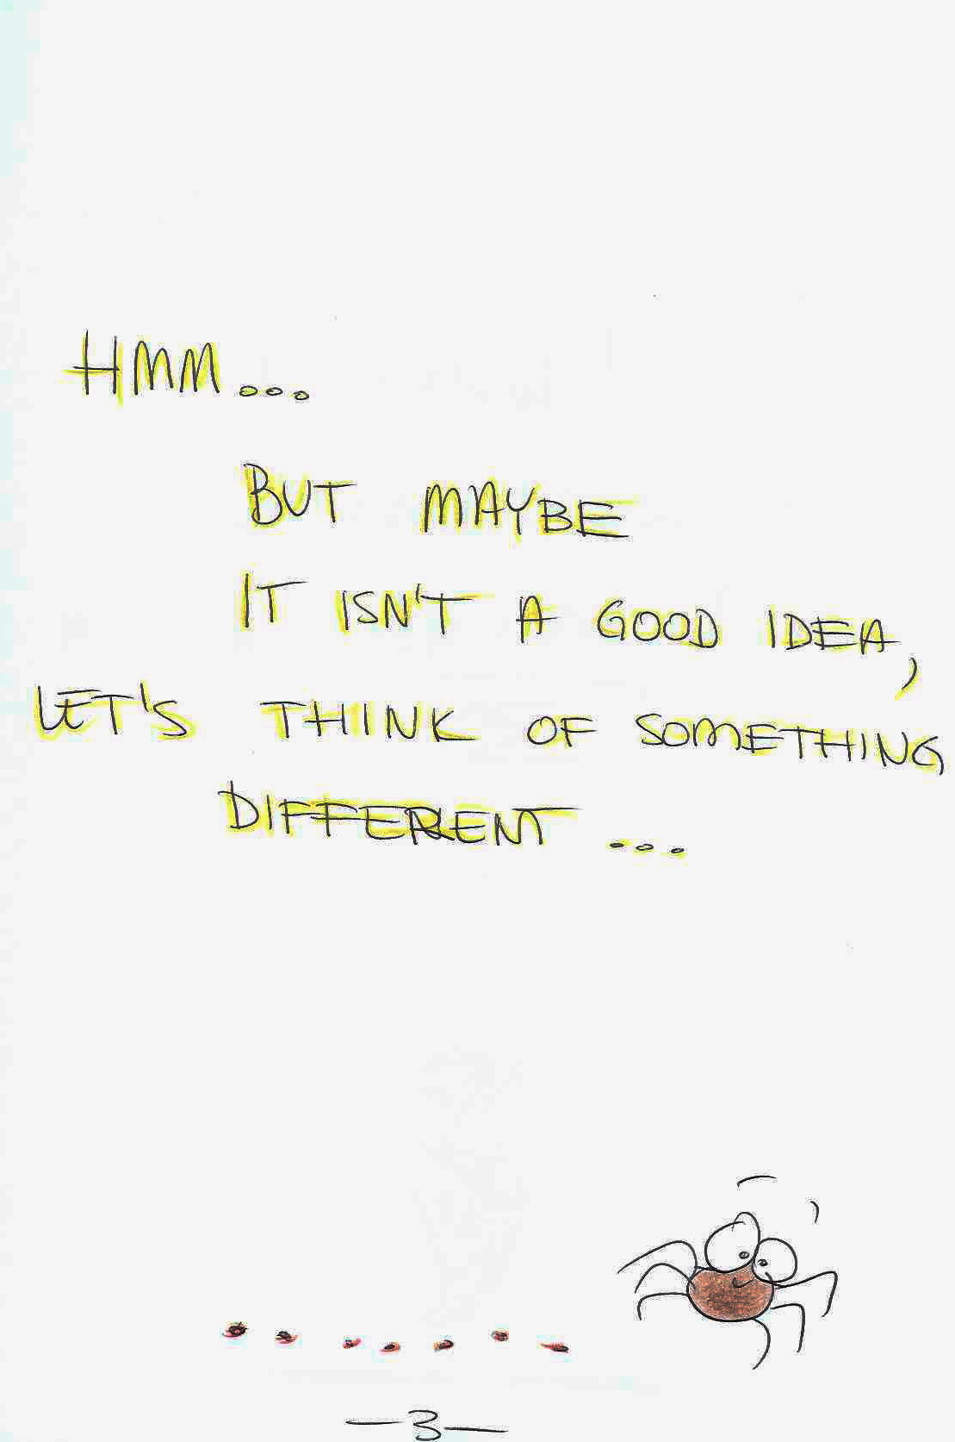
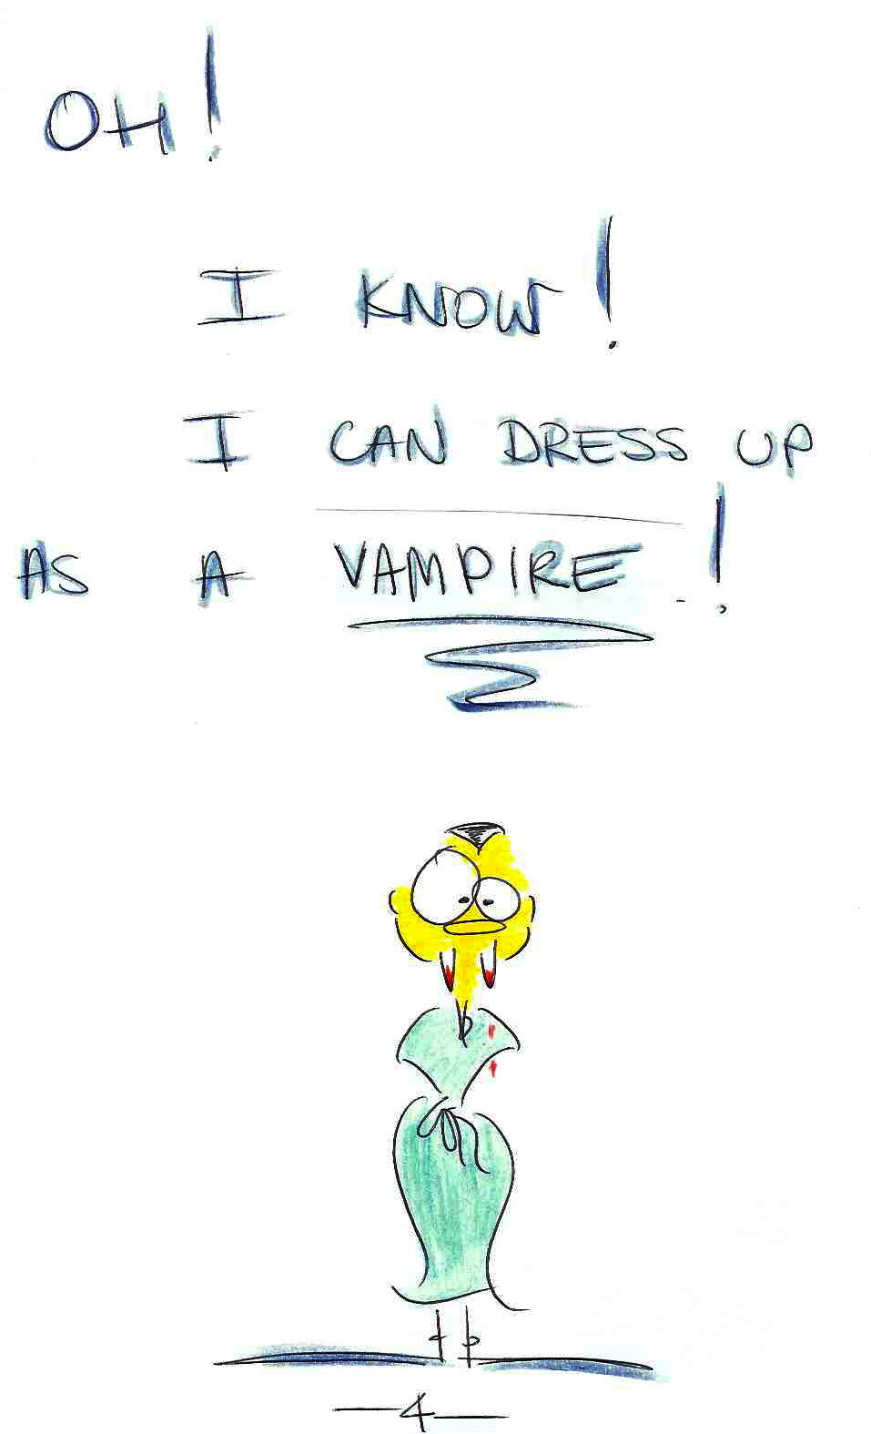
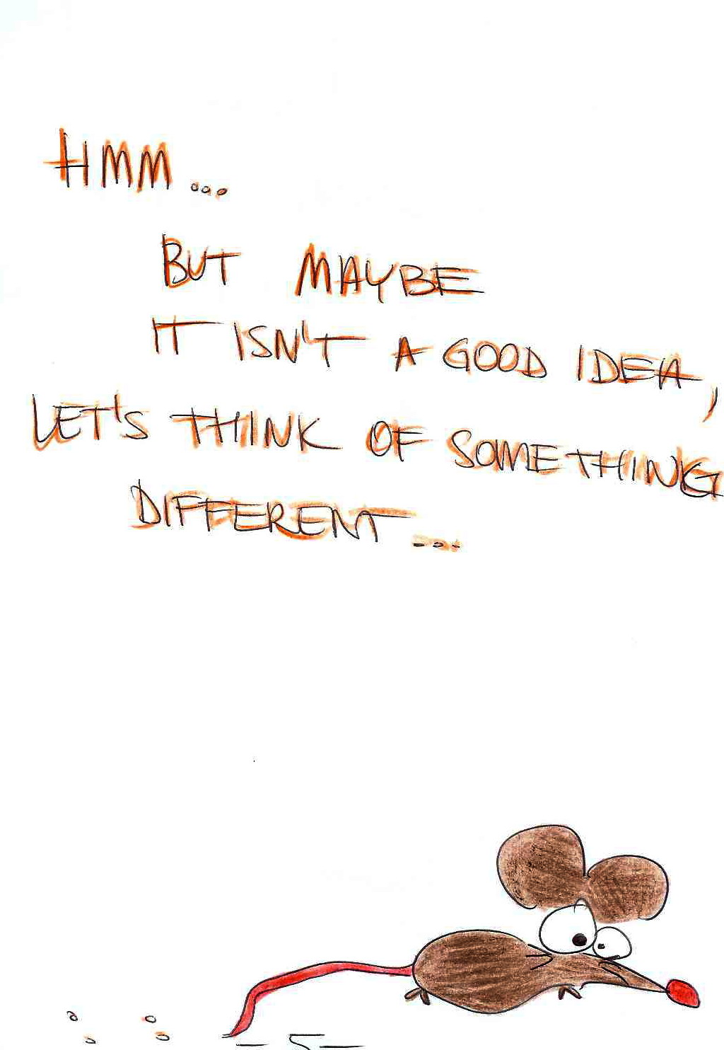

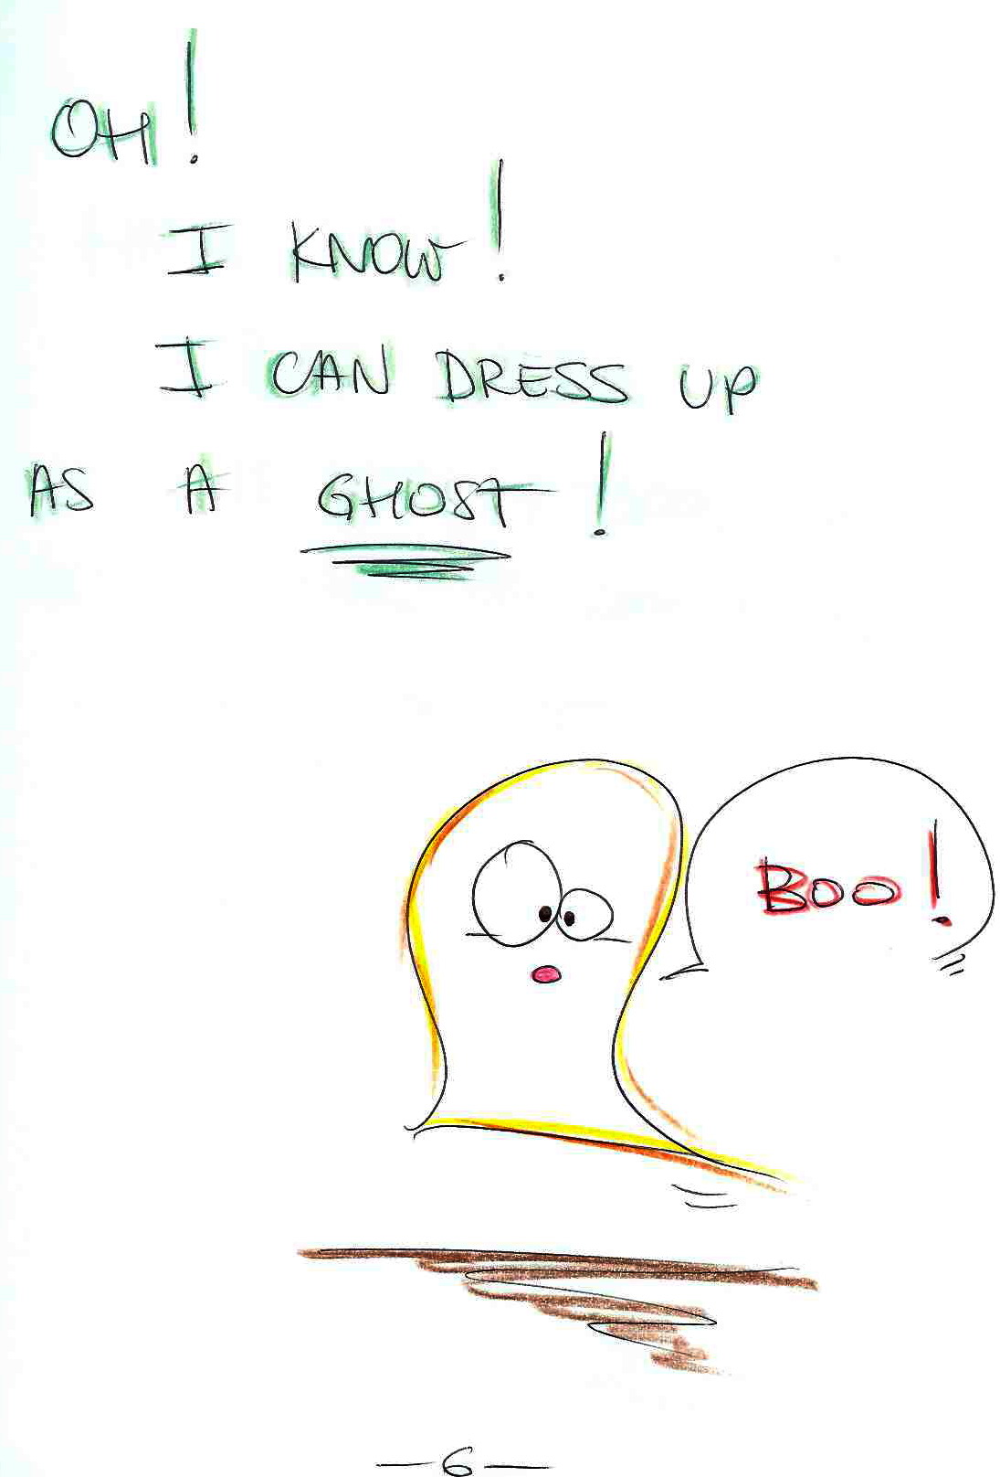
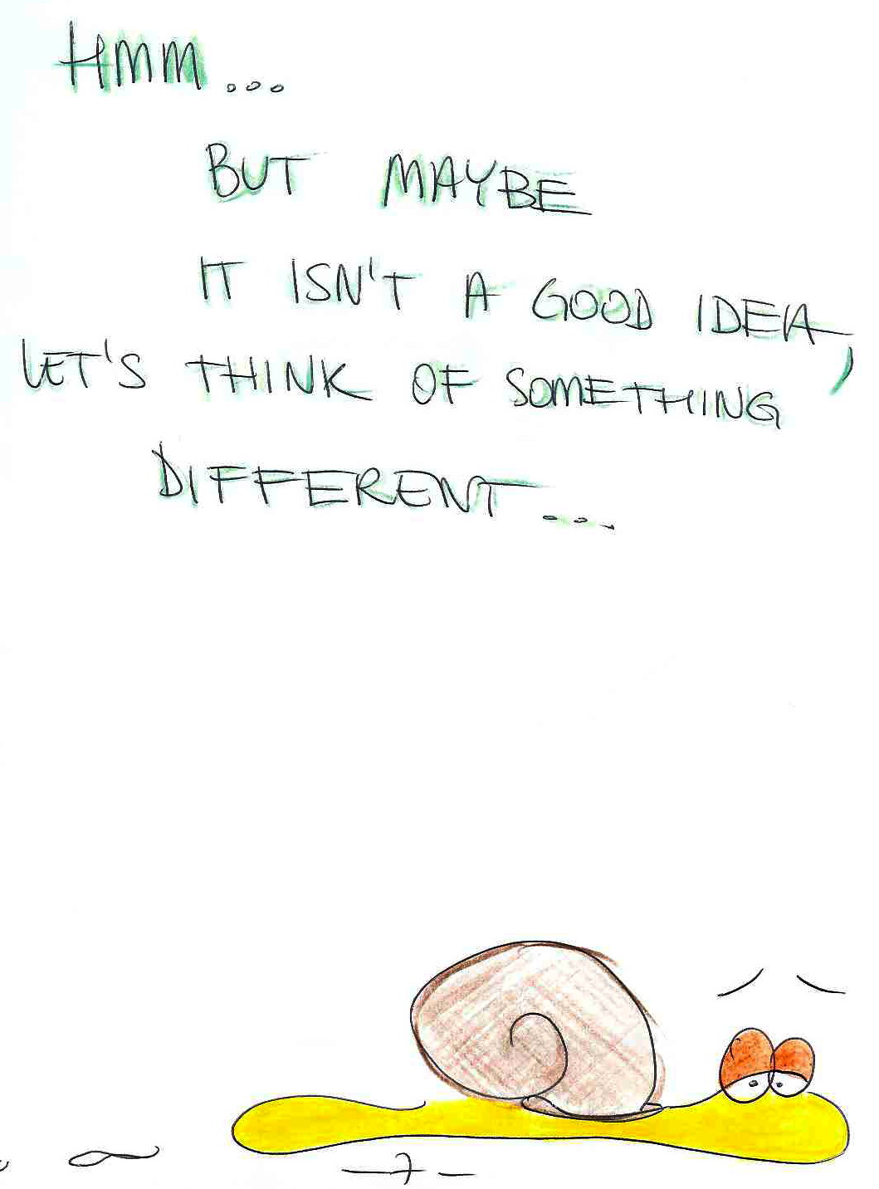
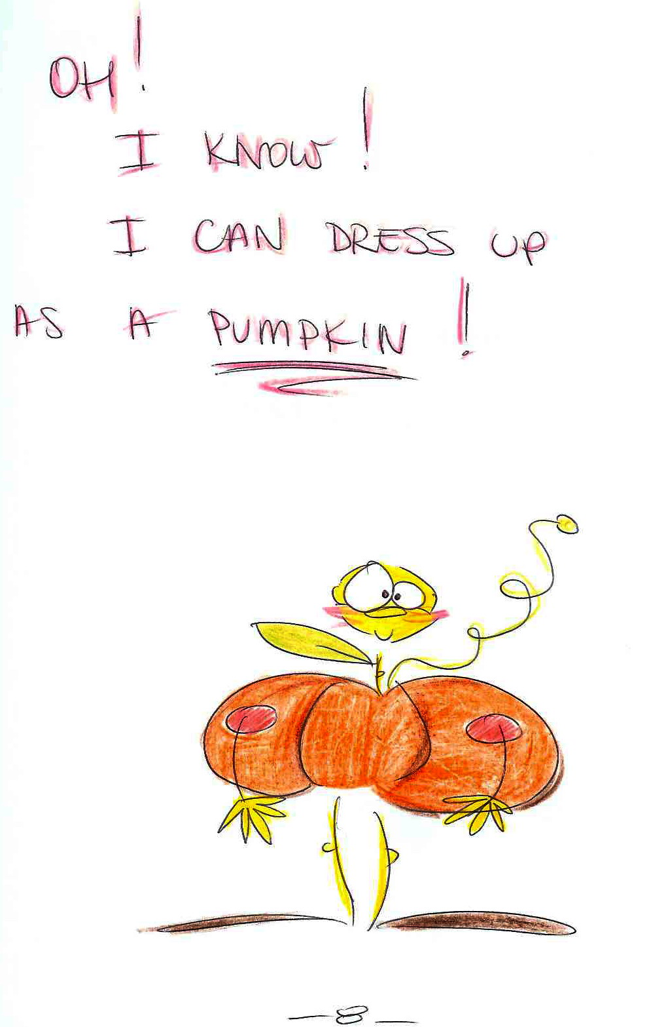

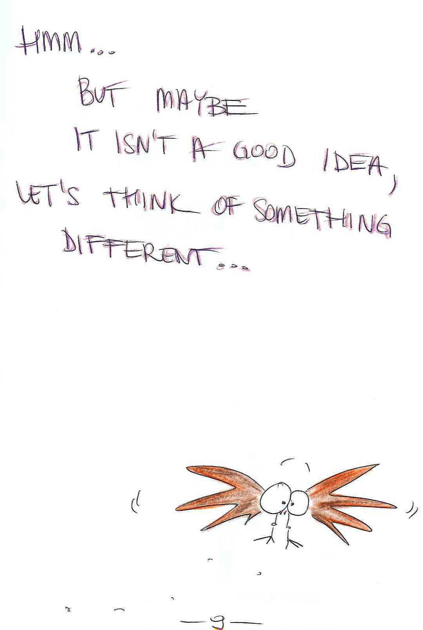
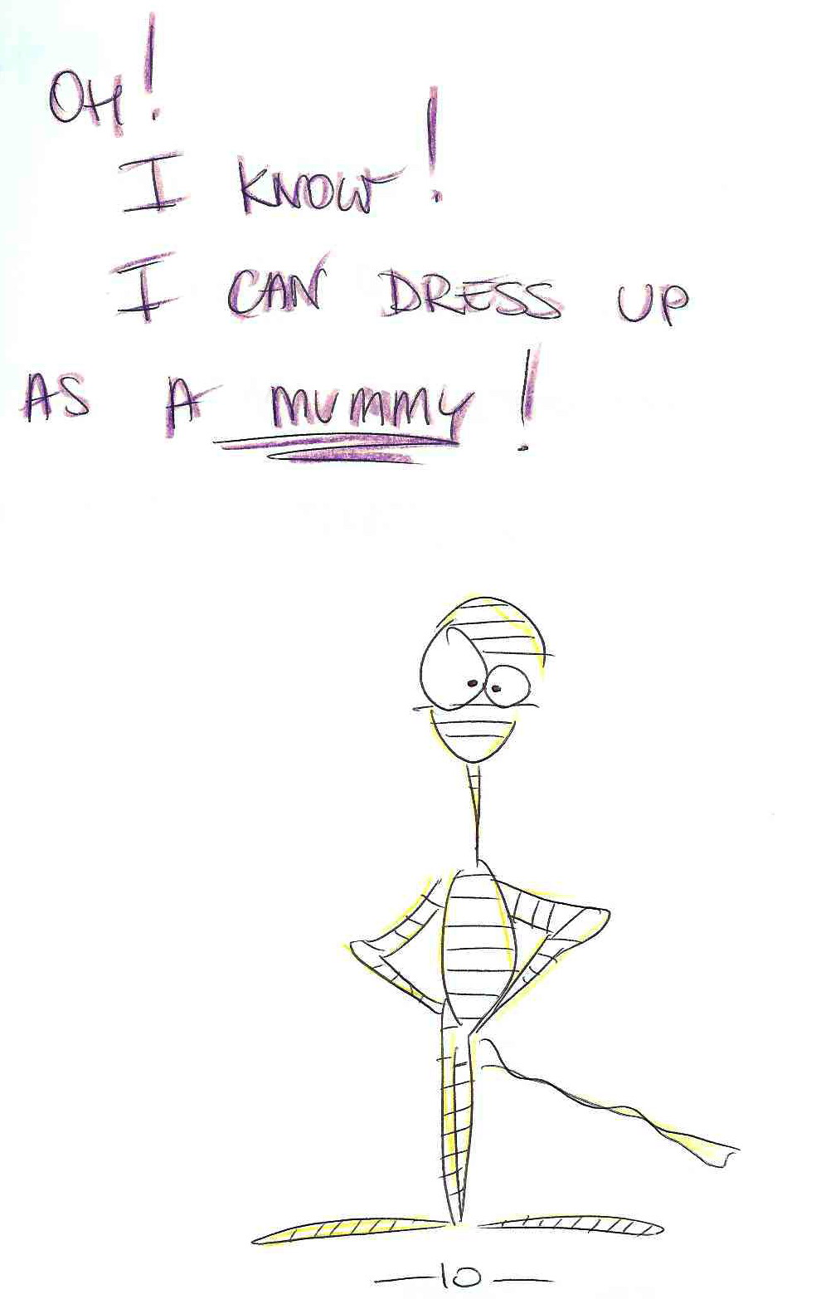
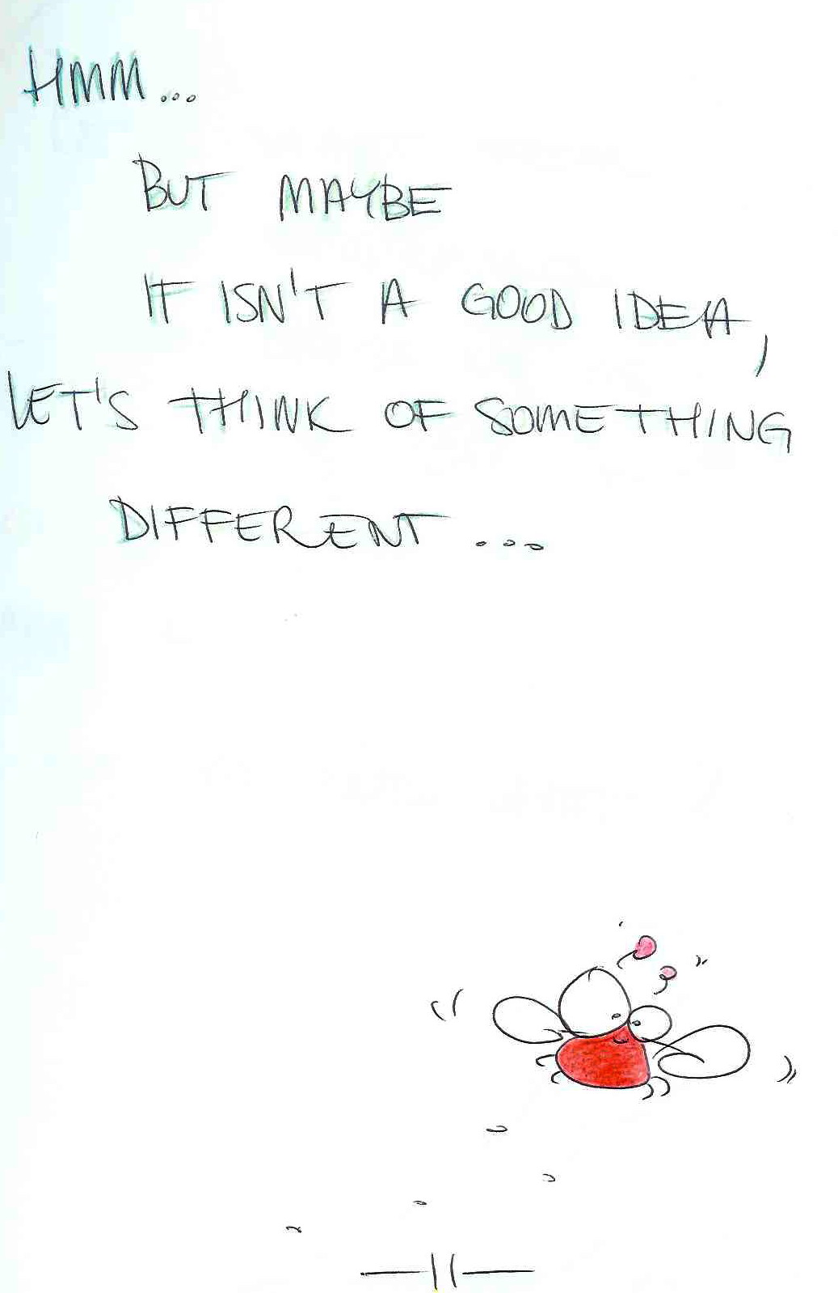

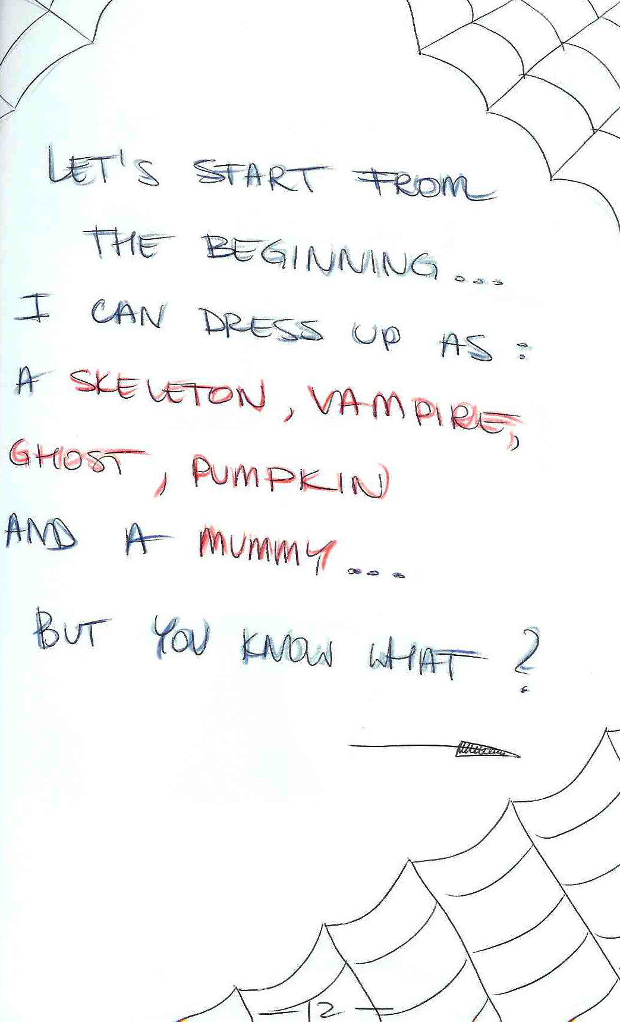
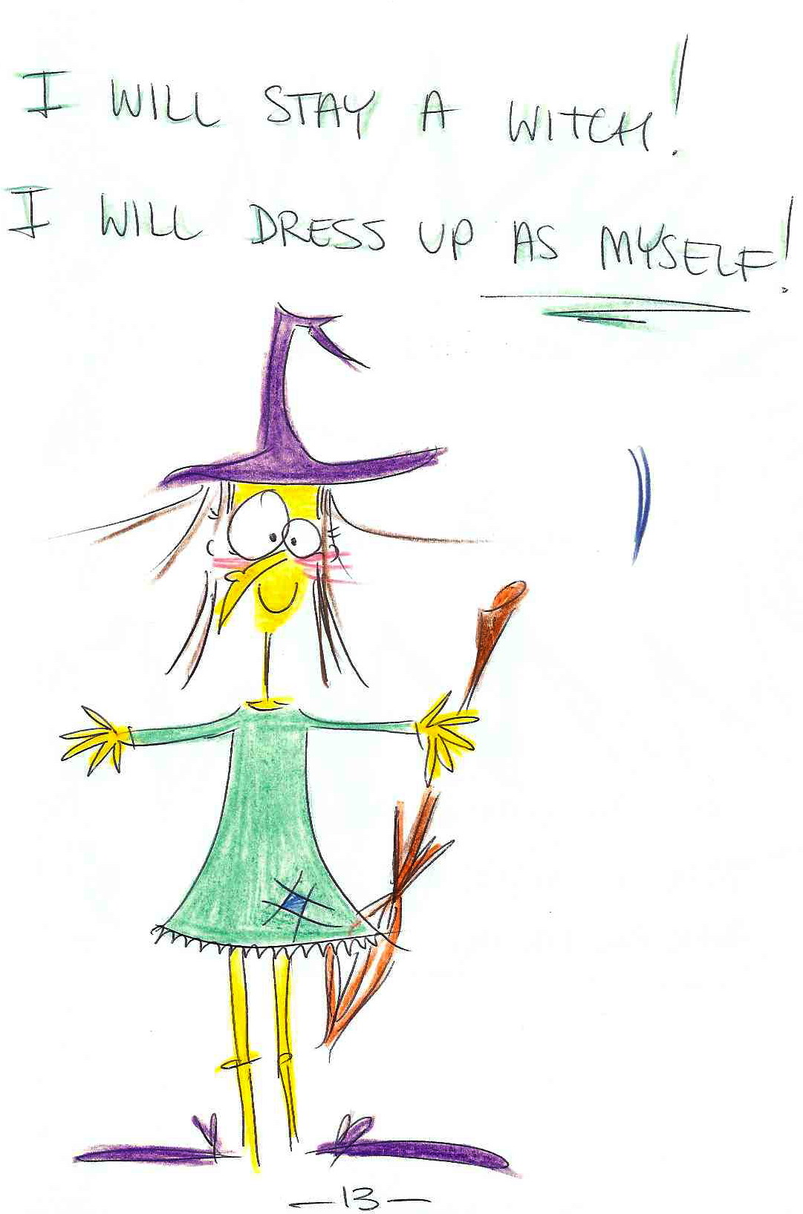
This introduction of vocabulary and drilling appeals especially to visual students. It requires some artistic skills from the teacher but is very rewarding.
Prepared by: Monika Marczak, Alicja Antosiak and Maria Pacan.

Text 2
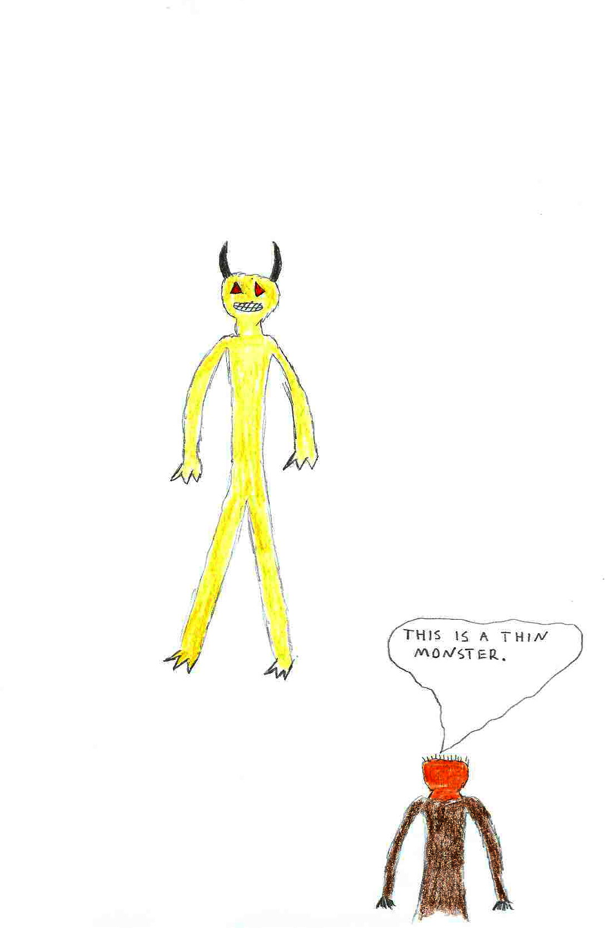
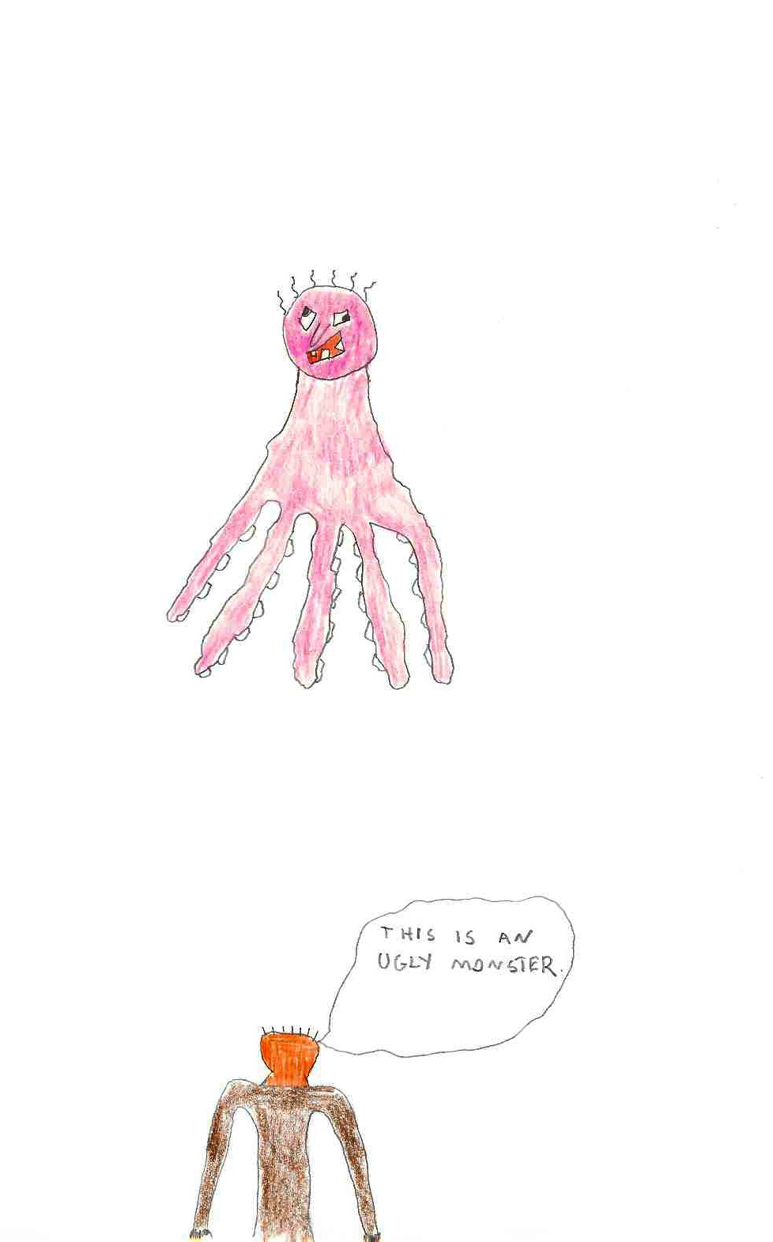
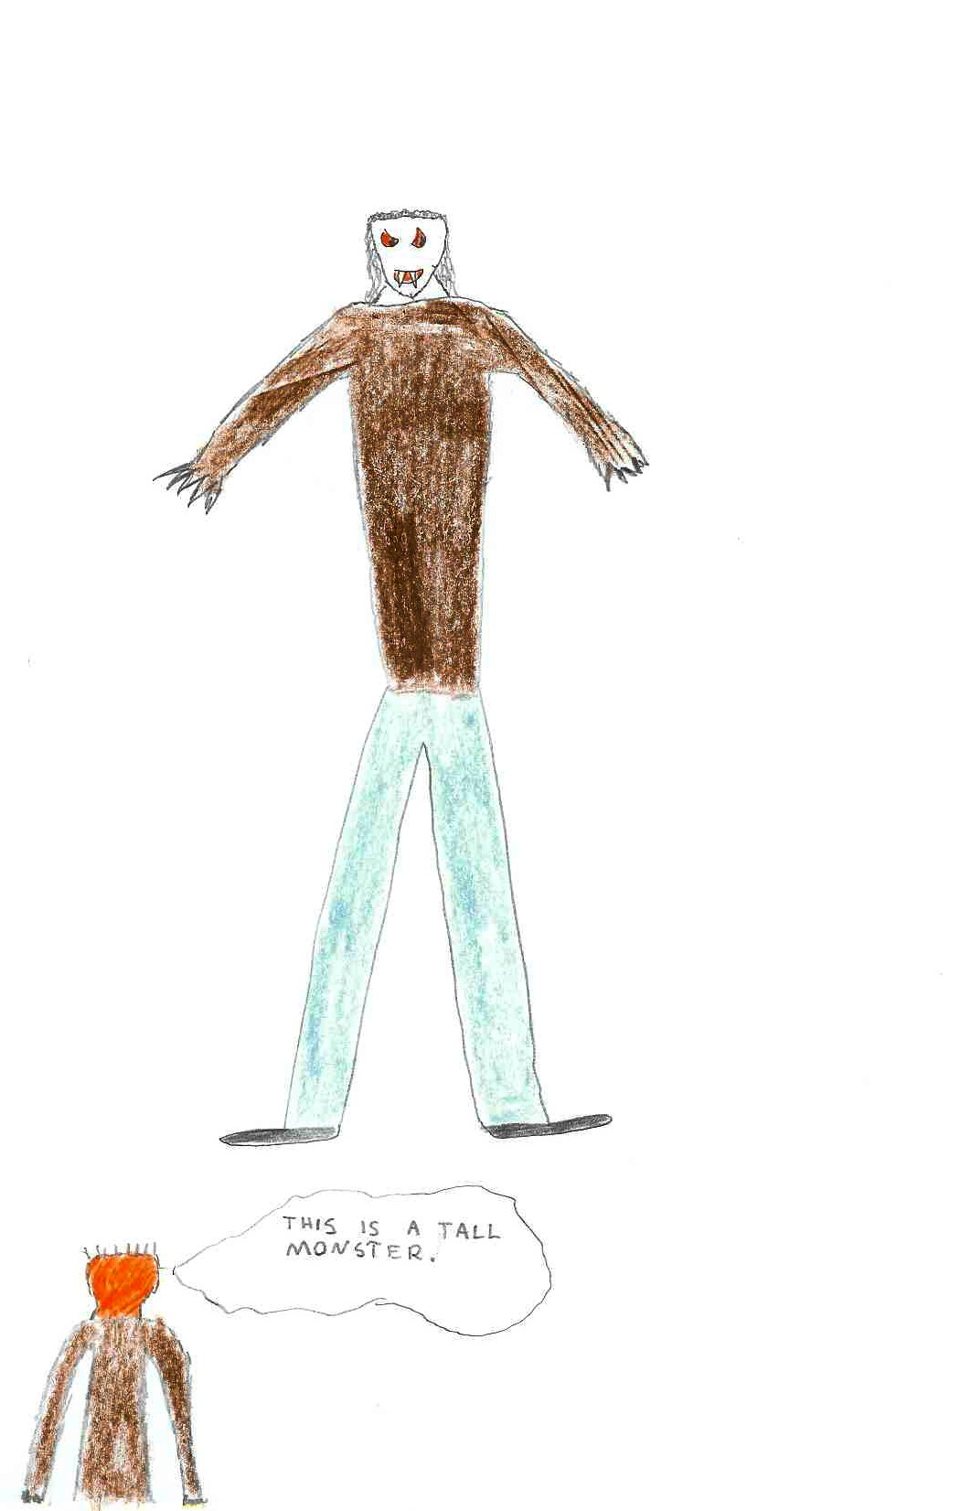

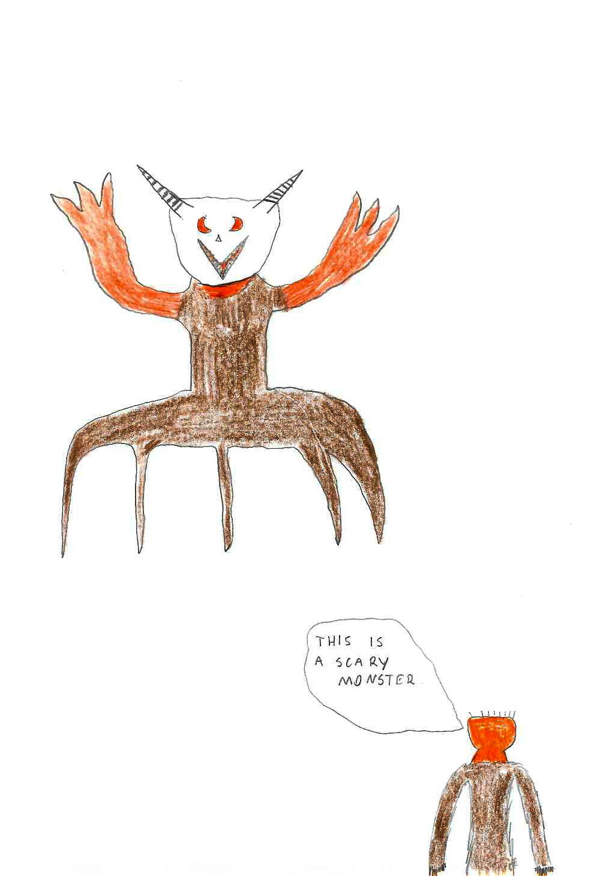
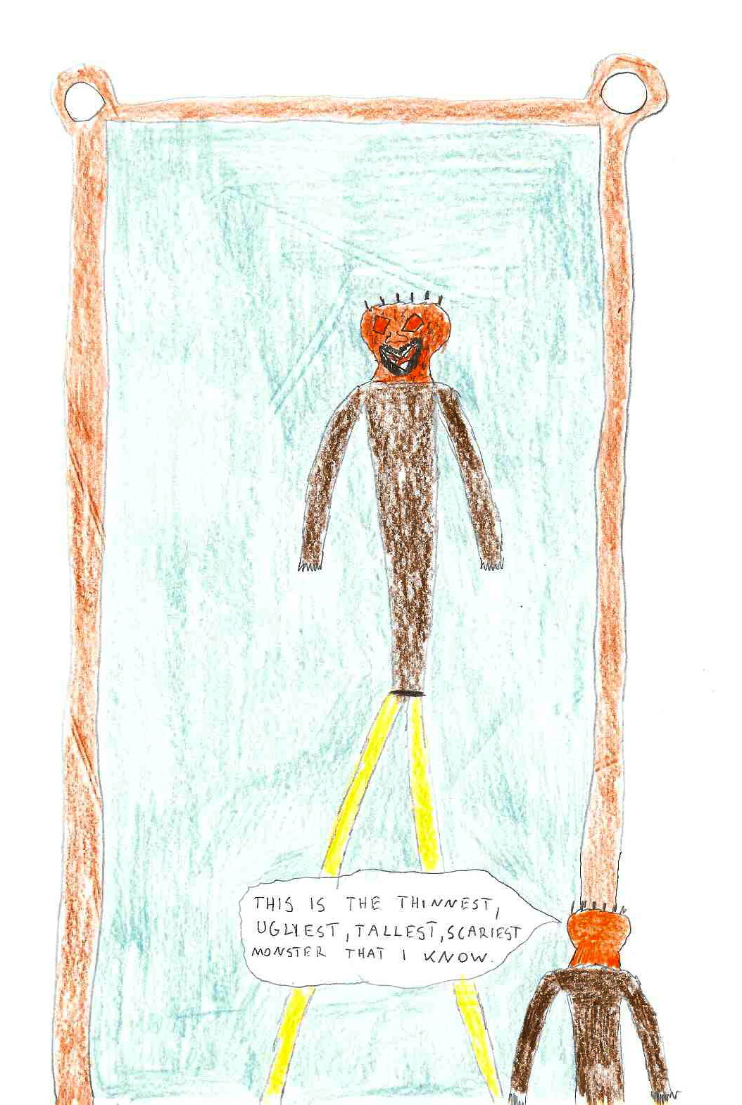
Story by:
Robert Wójtowicz, Marta Przybylska, Lourdes Guijarro

The next example shows an interesting combination of self-drawn pictures with a text. The text focuses on vocabulary and a grammar structures. What is worth pointing out that this exercise is easily prepared and therefore not time consuming.

Text 3
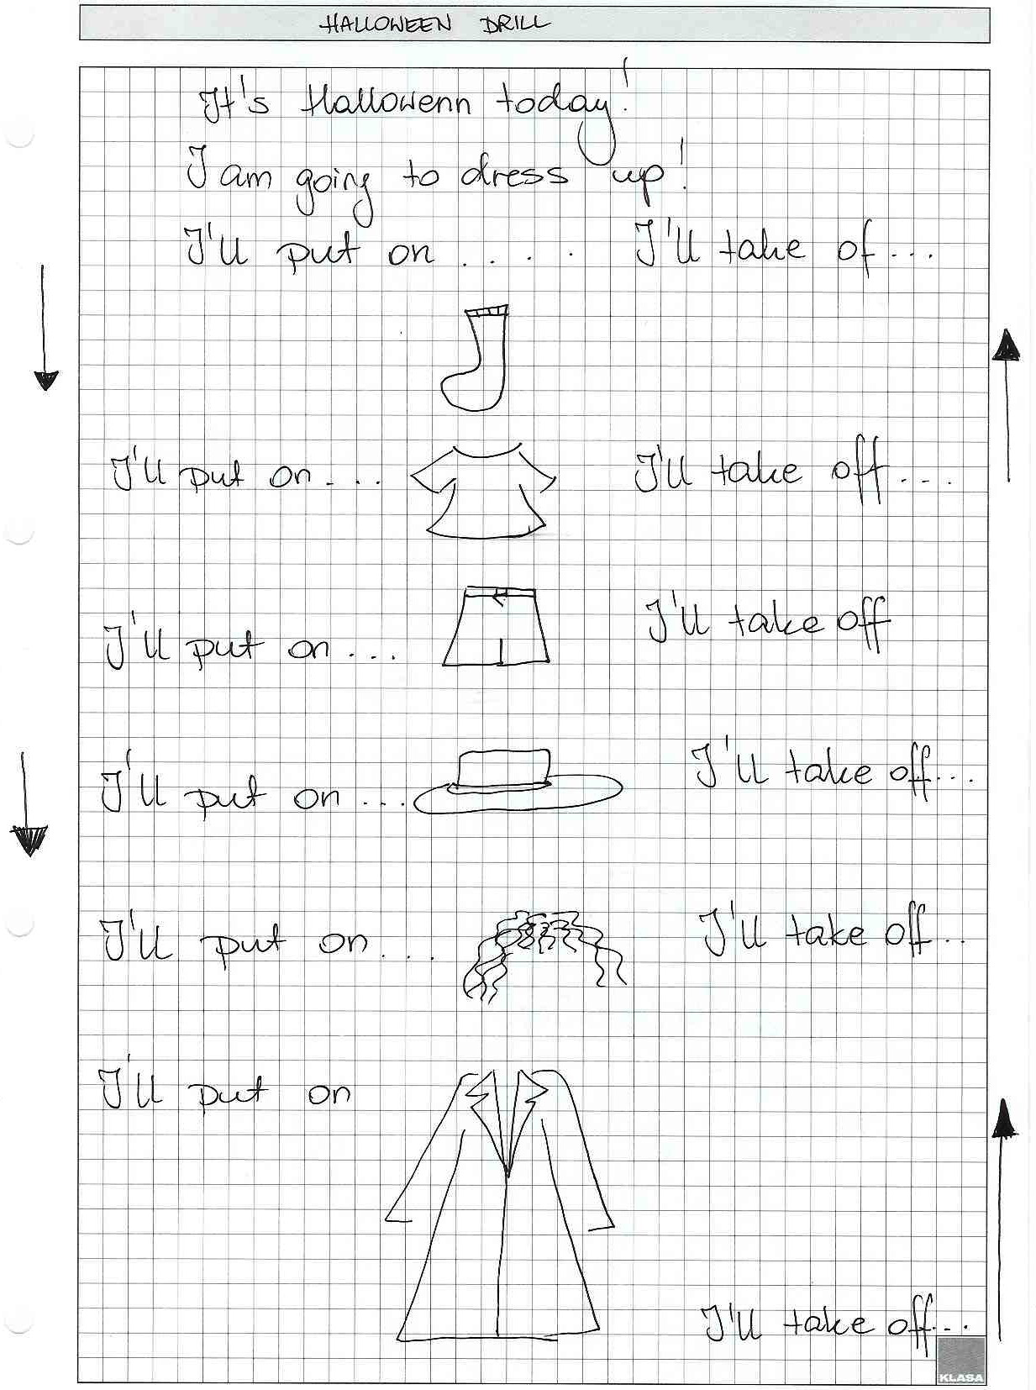

Exercise prepeared by Jonanna Hasse

The next set of examples are texts that focus more on words and there are no pictures.

Text 4

A drilling story for Halloween
- Today’s Halloween! I’m meeting my friends.

- I’m meeting a pumpkin.
Pumpkin: ‘Hello ! I’m a pumpkin.
- I’m meeting a wizard.
Wizard: Hello ! a pumpkin ,I’m a wizard!
- I’m meeting a witch.
Witch: Hello ! a pumpkin and a wizard, I’m a witch!
- I’m meeting a ghost.
Ghost: oh! Hello! a pumpkin, a wizard and a witch, I’m a ghost!
- I’m meeting a monster.
Monster: Hello ! a pumpkin, a wizard, a witch and a ghost, I’m a monster!
- I’m meeting a bat.
Bat: Oh! Hello! a pumpkin, a wizard, a witch, a ghost and a monster, I’m a bat!
Bang:
- Oh! Today’s Halloween! We’re going to play trick or treat!

- We’re going to get a lollipop.

- We’re going to get a cake.

- We’re going to get a candy.

- We’re going to get chocolate.

- We’re going to get marmalade.

- We’re going to get pudding.

Bang:
III. Oh! I have a toothache!
I’ve eaten too much chocolate.
I’ve eaten too much cake.
I’ve eaten too much marmalade.
I’ve eaten too much pudding.
Oh! I feel sick!
I’ve eaten too many lollipops.
I’ve eaten too many cakes.
I’ve eaten too many candies.
I’ve eaten too many fruit drops.
By Iwona Dudek, Natasza Kopeć

Text 5
Halloween, Halloween – how wonderful to be someone else…

If I go for a Halloween party, I dress like a ghost.
If I go for a Halloween party, I dress like a witch.
If I go for a Halloween party, I dress like a pumpkin.
If I go for a Halloween party, I dress like a skeleton.
If I go for a Halloween party, I dress like a death.
If I go for a Halloween party, I dress like a vampire.
If I go for a Halloween party, I dress like a wizard.

But what should I choose?

If I dress like a ghost, I will be too terrifying.
If I dress like a witch, I will be too ugly.
If I dress like a pumpkin, I will be too large.
If I dress like a skeleton, I will be too skinny.
If I dress like a death, I will be too depressing.
If I dress like a vampire, I will be too old.
If I dress like a wizard, I will be too strange.

Oh ,no!

I don’t want to be terrifying!
I don’t want to be ugly!
I don’t want to be large!
I don’t want to be skinny!
I don’t want to be depressing!
I don’t want to be old!
I don’t want to be strange!
By Małgorzata Dębska

Text 5

Halloween

Today is Halloween
So all little bats start to sing:
Come out pumpkins
Come out monsters
Come out skeletons
Come out jokers
It’s time for a party
Its time for a dance
It’s time for everyone to have a chance
To break their legs in a crazy dance.
By Anita Bork

Text 6
The scary night is coming…
Who knows what it will bring us?
Have you seen that huge bat with teeth razor-sharp?
No, I haven’t seen a vampire yet.
So watch your back…
Have you seen that supernatural creature with magic stick?
No, I haven’t seen a witch yet.
So beware…
Have you noticed that posture wrapped in bandage?
No, I haven’t noticed a mummy yet.
So be all eyes…
Have you met that dreadful spirit?
No, I haven’t met a ghost yet.
So be careful…
Have you been terrified tonight ?
No, I haven’t .
So what is wrong with Halloween?
Nothing, besides it’s tomorrow ;)
By Joanna Peka

An finally …
Text 7
Instruction

Here is Zieg.
Zieg is a monster. Try to be Zieg and introduce yourself, using the adjectives given below.

Example:

I’m Zieg. I’m a funny monster.

Now it is your turn

I’m Zieg. I’m a …………… monster.

- wicked
- vicious
- mischievous
- terrifying
- grey-eyed
- hairy

By Paweł Zieliński and Tomasz Frączek.

Conclusions

The texts have all been inspired by drills yet at the same time they are creative and fun. You can use them in class or write your own.

The Methodology and Language for Primary Teachers course can be viewed here.
The Creative Methodology for the Classroom course can be viewed here.

